1. Click on the Setting menu item from the Chrome option button [by clicking the three vertical dots].

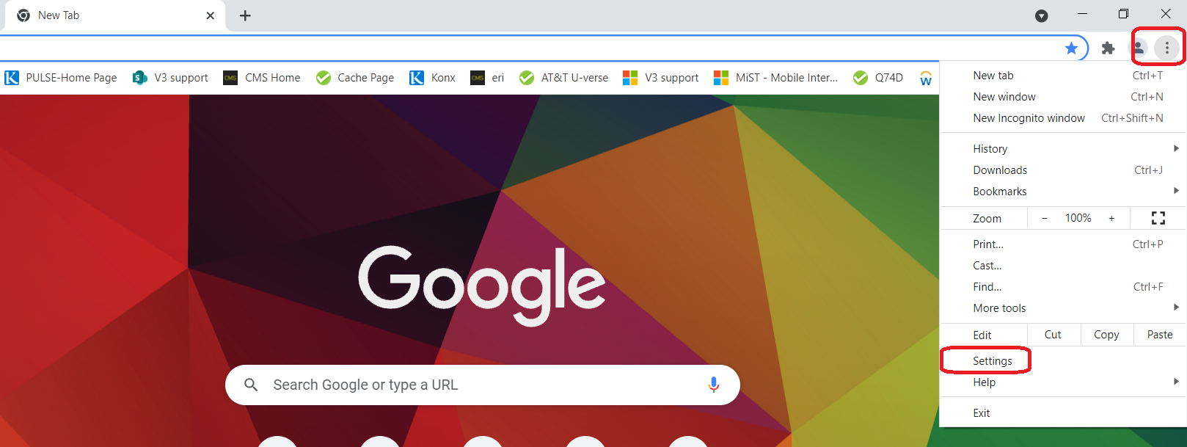

1. After clicking on the setting, a new window would appear with all Chrome setting menu items. From there please click on the “Extensions” menu item.

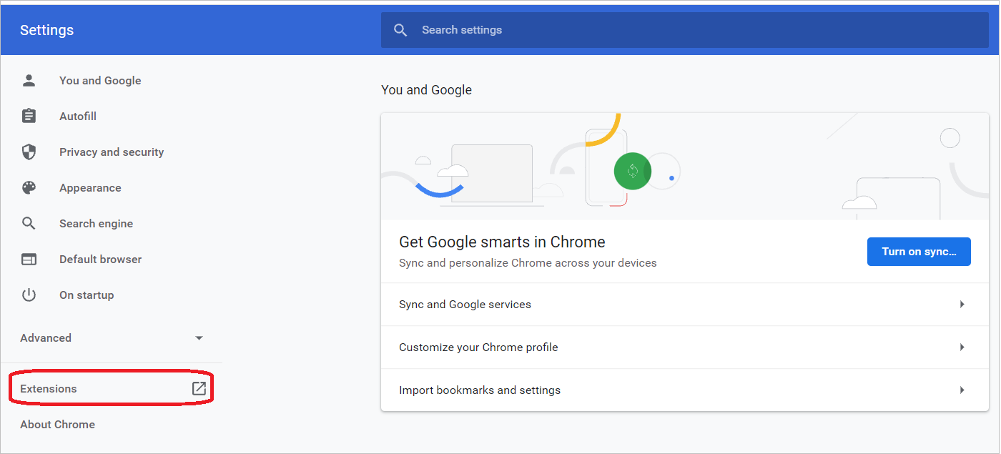

1. At the Extensions window, enable the 'Developer mode' and drag the unzipped file from your folder to this window. Automatically this Extension file will be added to Chrome.
2. After dragging the file into to Extension window, please disable “Developer mode”.
3. After successfully adding the testing tool, below is the example final screenshot of how it looks.

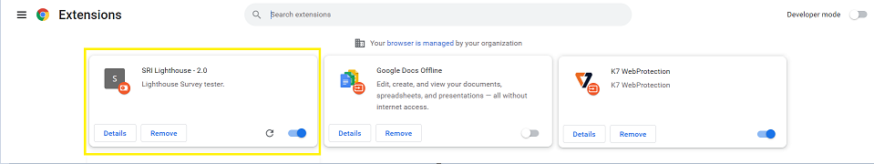

1. Now, take a test link on Chrome browser and can see the Testing tool features on the respective page. See the below screenshot for your reference.

